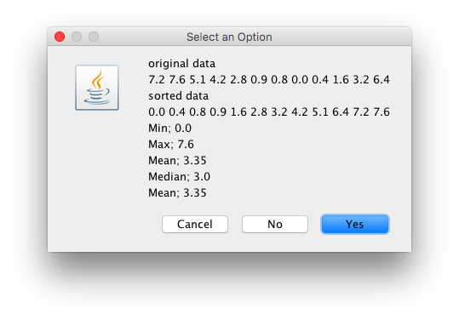

**import** java.util.Arrays;

**public** **class** Statistics {

**double**[] data;

**double**[] sdata;

//consturctor

**public** Statistics (**double**[] d) {

// double[] data;

// double[] sdata;

//create two double arrays of size d.length

data = **new** **double** [d.length];

sdata = **new** **double** [d.length];

//copy d array into arrays data and sdata

System.*arraycopy*(d, 0, data, 0, d.length);

System.*arraycopy*(d, 0, sdata, 0, d.length);

//sort array sdata

Arrays.*sort*(sdata);

}

//

**public** **double** findMin1(){ //method

**double** min = sdata[0];

**return** min;

}

**public** **double** findMax(){

**double** max = sdata [sdata.length-1];

**return** max;

}

**public** **double** findMean(){

**double** sum =0;

**for** (**int** i =0; i < sdata.length; i++)

{

sum = sum + sdata[i];

}

**double** mean = sum / sdata.length;

**return** mean;

}

**public** **double**[] getsortedData() {

**return** sdata;

//return sdata.clone();

}

**public** **double**[] getorigData() {

**return** data;

//return sdata.clone();

}

**public** **double** findMedian(){

**double** median=0;

//Declare variables

**int** index, indexHi, indexLo;

//Determine if the length is odd or even.

**if** ( (sdata.length %2) != 0 )

{

index = sdata.length / 2;

median = sdata [index];

}

**else**

{

indexHi = sdata.length / 2;

indexLo = indexHi - 1;

median = (sdata[indexLo] + sdata[indexHi] ) / 2;

}

**return** median;

}

}

**import** javax.swing.JOptionPane;

**public** **class** TestStatistics {

**public** **static** **void** main (String args [])

{

//input data

String in, out;

in = JOptionPane.*showInputDialog*("Enter data size");

**int** dataSize=Integer.*parseInt*(in);

//create double array

**double** [] x = **new** **double** [dataSize];

//input data. Need for loop to display the array

**for** ( **int** i=0; i<x.length; i++)

{

in = JOptionPane.*showInputDialog*("Enter data element");

x[i] = Double.*parseDouble*(in);

}

//create object and pass it to the array

Statistics stat = **new** Statistics (x);

//call the object method

**double** min = stat.findMin1();

**double** max = stat.findMax();

**double** mean = stat.findMean();

**double** median = stat.findMedian();

**double**[] sortedData = stat.getsortedData();

**double**[] origData = stat.getorigData();

//build output

out ="original data\n";

**for** (**int** i =0; i< origData.length; i++)

{

out = out + origData[i]+ " ";

}

out = out + "\n";

out = out + "sorted data\n";

**for** (**int** i =0; i< sortedData.length; i++)

{

out = out + sortedData[i]+ " ";

}

out = out + "\n";

out = out +"Min; "+ min + "\n";

out = out +"Max; "+ max + "\n";

out = out +"Mean; "+ mean + "\n";

out = out +"Median; "+ median + "\n";

out = out +"Mean; "+ mean + "\n";

JOptionPane.*showConfirmDialog*(**null**, out);

}

}